

STUDENT ACTIVITY FINANCIAL REPORT

DETAILS
Event Title | :
Organizing Club / Society | :
Date | :
Time | :
Venue | :
Submission Date | :

Revenue (Example)
No | Descriptions | Source of Income | Details/Breakdown | Total Amount
1. | Ticket sales | Students & Staff | 120 tickets x RM10 each | 1200
2. | Sponsorship | Milo | Monetary | 500
3. | Booth Rental | Rentals | 8 vendors x RM100 | 800
4. | Merchandise Sales | T-shirts and key chains | RM20 x 20 T-shirts  RM5 x 30 | 400
4. | Merchandise Sales | T-shirts and key chains | keychains | 150
5. | Club fund | Fundraising | Club Fund | 200
6. | SRC fund | SRC | F&B | 400
7. | SSH fund | SSH | Trophy | 300
Total Revenue |  |  |  | 3950

Expenses (must with receipt attachments)
No. | Items | Quantity |  | Unit Price (RM) | Amount (RM)
1. | F&B | 200 |  | 10 | 2000
Total expenditure |  |  |  |  | 2000

Total income after all expenses have been deducted (Revenue – Expenses) = RM1950

Receipts (Must be tally with total expenditure)
No | Receipt Picture/Image | Description | Total Amount (RM)
1. | 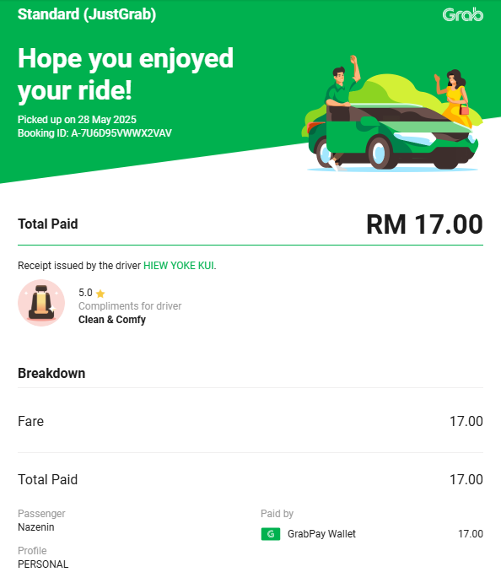 | Transportation | RM17.00
2.
3.
4.
5.
Total

Prepared by |  |  | Verified by
Name | : |  | Name | :
Designation | : | Secretary | Designation | : | Advisor
Signature | : |  | Signature | :
Date: | : |  | Date | :

