

IMU University Clubs & Societies Activity
TITLE: IMU DEBATE CLUB WELCOMING PARTY

Date:
Time:
Venue:

Organized by:
IMU DEBATE CLUB

- INTRODUCTION
The IMU Debate Club Welcoming Party 2025 is a casual and engaging event aimed at introducing new members to the club's vibrant community. This activity serves as a platform to foster connections between new and existing members, share the club’s vision and upcoming plans, and create a welcoming environment that encourages participation and collaboration. Through interactive games, light refreshments, and fun team-building activities, the event is designed to break the ice and set the tone for an exciting year ahead in debating and public speaking.

- OBJECTIVES
- To welcome new members to the Debate Club
- To foster bonding between new and existing members
- To introduce the club's vision, activities, and leadership team
- To create a fun and inclusive environment to build team spirit

- ACTIVITY DESCRIPTION
The welcoming party will include an introduction to the club, ice-breaking activities, games, a short speech by the President and Advisor, a showcase of past debate events, and a Q&A session for new members. Light refreshments will be provided.
Games | Description
Ice-breaking activity | - Two Truths and a Lie– Debate Edition: Each participant shares two true statements and one false statement about themselves. Others must "argue" which one is the lie and explain their reasoning.  - Speed Friending: Pair participants and give them 1–2 minutes to introduce themselves and answer a fun debate-themed question (e.g., "Is pineapple on pizza a crime?"). Rotate until everyone meets.
Games | - Mini Debate Battles: Two participants are given a random topic (serious or silly), and each has 1 minute to argue their side.  - Devil’s Advocate: Participants must argue against a topic they actually agree with.  - Debate Charades: Like regular charades, but each prompt is a topic or concept (e.g., "freedom of speech", "aliens exist"). The team must guess it through miming, then discuss briefly what it means.

- TARGET PARTICIPANTS
New and current members of the IMU Debate Club are invited. We are targeting around 20 new members and 30 existing members to join this welcoming party.

- TENTATIVE ITINERARY
Time | Activity | Description
2:00 PM – 2:15 PM | Arrival & Registration | Guests sign in, receive welcome packs (if any), light background music playing.
2:15 PM – 2:30 PM | Opening Remarks | Welcome speech by Club President and brief words from Club Advisor.
2:30 PM – 2:45 PM | Introduction to IMU Debate Club | Presentation on club vision, past achievements, and upcoming events.
2:45 PM – 3:15 PM | Ice-Breaking Activities | Fun interactive games to help members get to know each other.
3:15 PM – 3:45 PM | Group Activity / Mini Debate Game | Simple and engaging group challenge or debate-themed activity.
3:45 PM – 4:00 PM | Refreshments & Social Networking | Light snacks served, open mingling, music.
4:00 PM – 4:15 PM | Q&A Session | New members ask questions, give feedback, express interest in joining events.
4:15 PM – 4:30 PM | Closing Remarks & Group Photo | Thank you message, photo session, and reminder about upcoming meetings.

- PROPOSED BUDGET (If applicable)
Items | Description | RM | RM
Revenue/Fund | - Club fund | 200
Revenue/Fund | - Registration fees RM10 x 40 | 400
Revenue/Fund | Total Revenue/Fund |  | 600
Expenses | - Drinks | 100
Expenses | - Snacks | 100
Expenses | - Games | 100
Expenses | - Miscellaneous | 100
Expenses | Total Expenses |  | 400
Expenses | Net Income |  | 200

- EVENT COMMITTEE (Example)
Names | Designation | Task/Responsibilities
Amanda Lee | President | Overall event oversight & opening speech.
Nur Aisyah Rahman | Secretary | Registration & attendance tracking.
Kavitha Menon | Treasurer | Budgeting & refreshments.
Farid Azmi | Public Relation Officer | Promotion & media coverage.
Mei Xin Lim | Photography & closing coordination | Decorations & setup.
Ragunathan Gopal | Logistic coordinator | Event coordinator & logistics.
Daniel Wong | Activity coordinator | Ice-breaking & group activity lead.

- EVENT LAYOUT (If applicable)
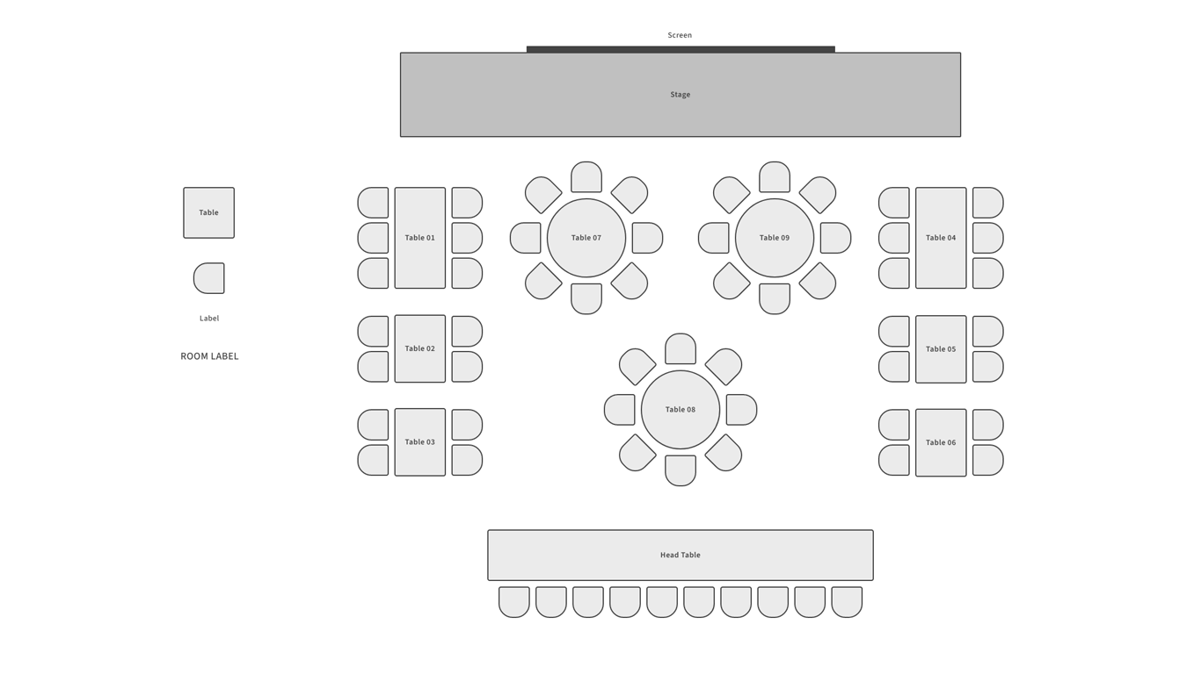

- CONCLUSION
The IMU Debate Club Welcoming Party aims to foster a sense of belonging and enthusiasm among new and existing members. By creating a fun, inclusive, and engaging environment, this event will serve as a stepping stone for active participation in future club activities and cultivate a stronger debating community within IMU. We look forward to a successful event with the support and participation of all involved.

Prepared by |  |  | Reviewed by
Name | : |  | Name | :
Designation | : | Secretary | Designation | : | Advisor
Signature | : |  | Signature | :
Date: | : |  | Date | :

