

Event Proposal:
IMU BALL 2025

Theme:
TIMELESS ELEGENCE

Date: Saturday, 17 February 2020
Time: 6.00 pm to 10.00 pm
Venue: Galasa

Organized by:
IMU STUDENT REPRESENTATIVE COUNCIL

- INTRODUCTION
An IMU Ball is more than just a social event—it’s a celebration of camaraderie, achievements, and milestones that mark the culmination of a significant chapter in students’ lives. At IMU University, where diversity and student excellence thrive, hosting an IMU Ball presents an opportunity to bring together students from various backgrounds to create cherished memories that will last a lifetime.

This proposal outlines the vision, purpose, and logistics for organizing an unforgettable IMU Ball for IMU students. The event aims to foster community spirit, reward students’ dedication throughout the academic year, and provide a platform for them to unwind, connect, and celebrate their journey at IMU.

With a theme tailored to elegance and inclusivity, this IMU Ball will feature captivating entertainment, delightful dining, and a dynamic program designed to ensure every student feels valued and included. By hosting this memorable occasion, IMU strengthens its commitment to holistic student development and creating experiences that resonate far beyond the classroom.

Theme: Timeless Elegance (If applicable)

Step into an evening of classic sophistication at the IMU Ball: Timeless Elegance, where tradition meets glamour. Inspired by the grace of bygone eras, this event invites students to celebrate in style with an ambiance of refined charm and polished beauty.

- Dress Code:
Ladies are encouraged to wear floor-length gowns in timeless shades—black, navy, burgundy, or champagne. Gentlemen should arrive in tailored suits or tuxedos with dress shoes. Think vintage glamour with a modern twist—simple, elegant, and poised.

- Decorations:
The venue will be adorned with crystal chandeliers, soft candlelight, velvet drapes, and gold accents. A palette of ivory, gold, and deep jewel tones will create a luxurious and warm atmosphere, with classical music and ambient lighting setting the tone for an unforgettable night.

- OBJECTIVES
- Celebrate Student Achievements
Recognize and honour the hard work, dedication, and accomplishments of QIU students throughout the academic year.
- Foster Unity and Inclusion
Create a welcoming and inclusive environment where students from diverse backgrounds can connect and celebrate together.
- Enhance Student Experience
Provide a memorable social event that enriches the overall university experience and strengthens the sense of community among students.
- Promote Positive Social Interaction
Offer a platform for students to build new friendships, strengthen existing bonds, and network in a relaxed and enjoyable setting.

- PROPOSED ACTIVITY
- Dinner and Networking
A buffet or plated dinner featuring a variety of cuisines to cater to diverse tastes, with time for socializing and networking.
- Entertainment Performances
Live music, dance performances, or stand-up comedy by talented QIU students or invited artists.
- Prom King and Queen Voting
An engaging election where attendees vote for the Prom King and Queen, with a grand crowning ceremony.
- Dance Party
A DJ or live band leading the dance floor with a mix of upbeat and slow songs to suit all preferences.
- Awards and Recognition
Presentation of fun and creative awards such as "Best Dressed," "Most Charismatic," or "Life of the Party" to celebrate individual contributions.
- Lucky Draw
A raffle or lucky draw with attractive prizes to add excitement to the event.

- TENTATIVE ITINERARY
Time | Itinerary
6.30 PM – 7.00 PM | Guest Registration
7.00 PM – 7.15 PM | Arrival of VIPs (with Dance Club)
7.15 PM – 7.20 PM | Introduction Speech by Emcee
7.20 PM– 7.40 PM | VIP’s Speech
7.40 PM – 7.45 PM | Video Session
7.45 PM – 7.50 PM | Alumni Speech
7.50 PM – 8.00 PM | Special Performance
8.00 PM – 8.45 PM | Dinner (Food Serving Session)  Student performances
8.45 PM – 9.00 PM | Election of Prom King and Prom Queen
9.00 PM – 9.20 PM | Lucky Draw Session
9.20 PM - 9.40 PM | Performance by Music Club
10.00 PM | Closing

- PARTICIPANTS & TICKET DETAILS (If applicable)
The QIU Prom Night is designed for undergraduate and postgraduate students, staff, alumni, and the general public, fostering an inclusive atmosphere. Ticket prices are RM 60 for students and alumni, and RM 80 for staff and the public, ensuring accessibility for all. We are targeting approximately 400 attendees.

- EVENT COMMITTEE (Example)
Names | Designation | Task/Responsibilities
Amanda Lee | Event Director | - Oversee the planning and execution of the prom.  - Coordinate with all committees.  - Ensure event goals are met.
Bruce Lee | Secretary | - Prepare and distribute agendas, minutes, and schedules.  - Manage correspondence and documentation.
Jet Lee | Treasurer | - Prepare and manage the event budget.  - Handle all payments, receipts, and reimbursements.  - Ensure financial accountability.
Michelle Lim (Lead)  Kevin Smith | Programme Coordinator | - Plan the prom program and activities (e.g., speeches, dances, awards).  - Coordinate with emcees, DJs, and performers.  - Prepare scripts and materials.
Raj Kumar (Lead)  Ana Sofia | Logistics Committee | - Book the venue and arrange seating plans.  - Set up sound, lighting, and decoration.  - Manage AV and other technical needs.
Emily Tan (Lead)  Ahmad Zain | Registration Committee | - Handle ticket sales and attendee registrations.  - Manage guest lists.  - Coordinate on-site check-ins.
Nathan Chong (Lead)  Mei Lin | Publicity Committee | - Design and share promotional materials (e.g., posters, social media posts).  - Promote the event on campus and online.  - Create a buzz to attract participants.
Jason Ong (Lead)  Aisha Malik | Sponsorship Committee | - Identify and approach potential sponsors.  - Secure sponsorships in cash or kind (e.g., decorations, prizes).  - Ensure proper acknowledgment of sponsors.
Sophie Tan (Lead)  David Lim | Hospitality Committee | - Arrange meals, snacks, and beverages.  - Set up food and drink stations.  - Ensure smooth service throughout the event.
Kevin Tan (Lead)  Nora Ahmad | Awards and Souvenirs Committee | - Organize awards (e.g., Prom King and Queen, Best Dressed).  - Procure and distribute prizes and souvenirs.  - Ensure accurate engraving or labeling.
Mark Lee (Lead)  Lisa Tan | Security and Safety Committee | - Manage crowd control and ensure safety during the event.  - Coordinate with security personnel (if hired).  - Handle emergencies and first aid.
Ethan Chong (Lead)  Linda Ng | Photography and Videography Committee | - Capture photos and videos of the event.  - Set up photo booths or designated photo spots.  - Edit and share photos/videos post-event.

- EVENT LAYOUT (If applicable)
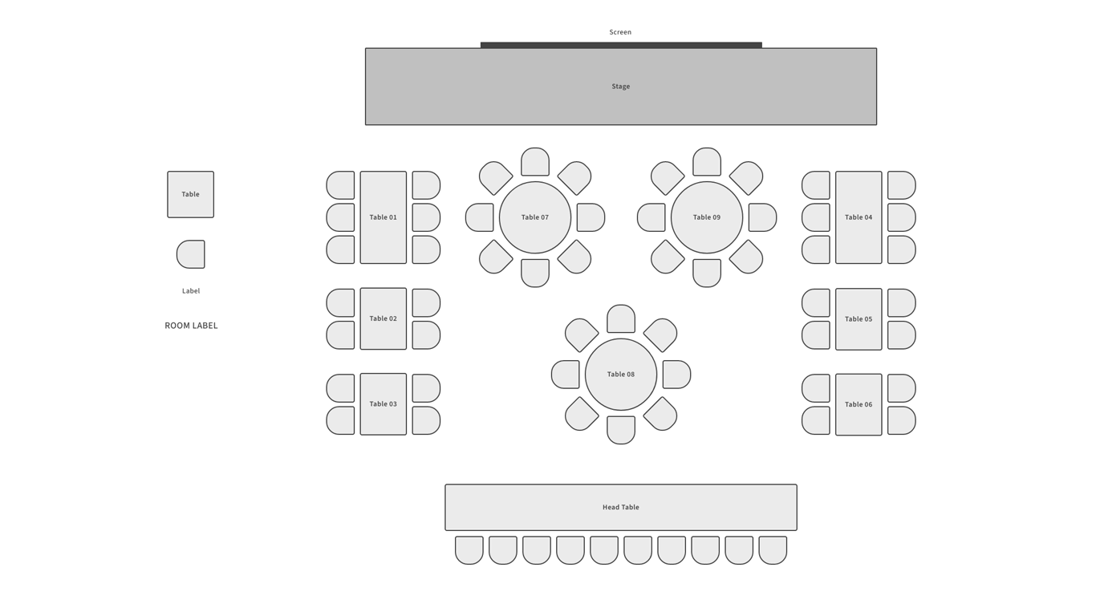

- PROPOSED BUDGET
Items | Description | RM | RM
Revenue | - All IMU Staff/Public/Alumni – RM80 x 100 pax | 8,000
Revenue | - All IMU active students – RM65 x 250 pax | 16,250
Revenue | - All Committee/Performance/Student Helper – RM50 x 50 pax | 2,500
Revenue | - Targeted Sponsorship Funding | 30,000
Revenue | Total Revenue |  | 56,750
Expenses | - Venue + Food + LED Screen | 26,000
Expenses | - 6% SST | 1,560
Expenses | - Decoration | 3,000
Expenses | - Poster Printing – A4 size | 30
Expenses | - Bunting Printing – RM20 x 2 buntings | 40
Expenses | - Certificate Printing – RM1 x 50 pcs | 50
Expenses | - Gift (Lucky Draw) | 700
Expenses | - Sash & Crown | 50
Expenses | - DJ | 1,000
Expenses | - Miscellaneous | 2,000
Expenses | Total Expenses |  | 34,430
Expenses | Gross Income |  | 22,320
 | Charity | RM 3 x400 tickets | 1,200
 | Net Income |  | 21,120

- CONCLUSION
The IMU Ball: Timeless Elegance promises an evening of grace, celebration, and unforgettable memories. More than just a night of glamour, it is a tribute to the students’ hard work, friendships, and personal growth. As the curtain falls on this chapter, the IMU Ball will stand as a lasting symbol of unity, achievement, and the timeless spirit of the IMU community.

Prepared by |  |  | Reviewed by
Name | : |  | Name | :
Designation | : | Secretary | Designation | : | Advisor
Signature | : |  | Signature | :
Date: | : |  | Date | :

